A COBRA EXPERIENCE

FULL DAY SELF‑DRIVE COBRA EXPERIENCE
08:30 – 16:30 • Cape Town, South Africa
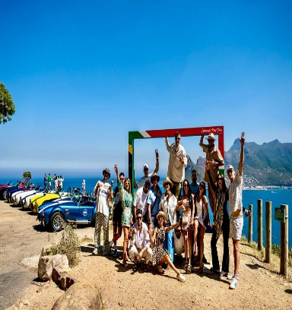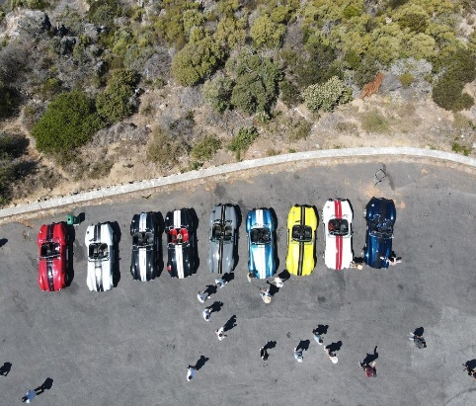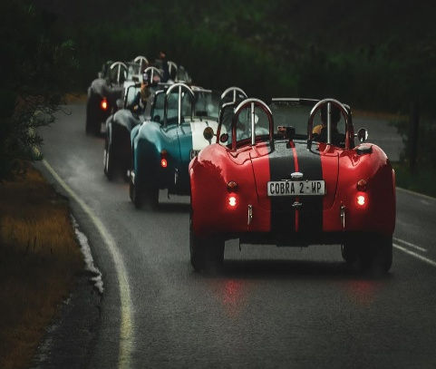
It’s not yours, but for the next few hours its yours!
Slip into the low‑slung seat of a classic Cobra, feel the rumble under you, and let Cape Town’s most iconic roads unfold in front of you. This isn’t just a drive — it’s a head‑turning, wind‑in‑your‑hair, open‑top adrenaline moment wrapped in pure luxury.
For the next few hours, the city becomes your playground, and the Cobra becomes your statement piece.
WHERE YOU CAN GO
Whether you prefer coastal views or countryside charm, the Cobra is the perfect way to experience Cape Town’s most celebrated destinations.
- Cape Peninsula Highlights
- Boulders Beach and its famous penguins
- Cape Point’s dramatic cliffs and ocean vistas
- Hout Bay Harbour and local markets
- Noordhoek’s long, sweeping coastline
- Constantia’s lush wine valley
Cape Winelands Option
Spend the day exploring Stellenbosch and Franschhoek — boutique shops, wine estates, mountain passes, and charming cafés that capture the essence of Cape heritage.
We provide turn‑by‑turn itineraries directly to your smartphone or GPS so you can enjoy the drive without worrying about navigation.
ACTIVITY DETAILS
- Duration: 8 hours
- Operating Times: 08:30 – 16:30
- Location: Foreshore, Cape Town
- Weather: Operates in safe weather conditions
WHAT TO WEAR & BRING
- Comfortable clothing, closed shoes, warm jacket
- Valid driver’s license
- Credit card for security hold
- Cash for toll roads
Passenger: One free passenger may join you for the day.

REQUIREMENTS
- Minimum age: 23
- Valid driver’s license required
INCLUSIONS
- Pick up at hotel
- Drop off at site
- 110 km free mileage
- Route itinerary loaded onto your device
- Pick up at site
- Drop off at hotel

EXCLUSIONS
- Fuel
- Additional mileage at R20.00 per km
- Chapman’s Peak Drive (restricted for safety reasons)
ADDITIONAL NOTES
- R4500 Self Drive
- Fuel must be replenished on return
- Extra driver fee: R500
- Mileage over 110 km charged at R20.00 per km
SECURITY & LIABILITY HOLDING FEE
A R15,000 pre‑authorisation is placed on your card to cover insurance excess, damage, fines, or recovery costs. Any unused amount is released after inspection.

Cash deposit: R20,000 or $1200
Cash deposits for sunset/sundowner hires may only be collected from 08:30 the following day.

T’s & C’s apply.

Frequently asked questions
- I have rented the car but have nowhere to go? An itinerary will be drawn up while the guest complete the paperwork.
- Is Safety a concern? All our cars are Factory built, and all our vehicles comply with all regulations set out by the South African Department of Transport. Safety along with a memorable experience are the two most important factors for our Brand.
- How many people can you accommodate? We can currently take up to 10 pax in Backdraft Cobra’s at a time but have a few other great classics we can offer in conjunction to accommodate larger groups. (Up to 20 pax can be arranged)
- What if it rains? We have a flexible wet weather policy. The drive will take place in all safe weather conditions permitting. If you wake up and find it is raining we will allow rescheduling of the experience or issue you with a voucher valid for 3 years to take up the experience at a convenient time.
- What do I need to bring with? Bring along your driver’s license, credit card and cash for refuelling the car. All our cars have pre-installed Go-Pro mounts and we provide Go-Pro and SD card rental packages allowing you to capture the day on film to take home and remember for years to come. Along with this we offer refreshments as well as t-shirts and caps to purchase as well as blankets to keep the chills away in winter.

